TUTORIAL 3: Trinity River

In this example, data from the Trinity River in Northern California is used. It is a stretch of approximately one mile of river corridor just south of Junction City, CA, located near river mile 82, near the Sheridan Creek Rehabilitation site. An aerial view of the site is shown in Fig. 1. This tutorial covers all the steps needed to accomplish a successful simulation, from importing the topographic data and setting up a computational mesh, to running SToRM and visualization and analysis of the results. In particular, it will be shown how to determine if a steady state solution has been reached and how to use measured free surface elevations to calibrate the model.

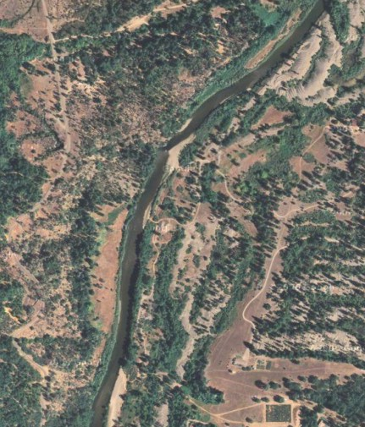

Figure 1.

Import Data

The first stage consists in reading the topography into MD_SWMS and creating a computational grid.

- Importing the topography from file Trinity.tpo (File | Import | Topography).
- Set the grid to unstructured mesh (Grid/Mesh | 2D Unstructured Mesh).
- Change the perspective view to undistorted Cartesian view by clicking on the button (bottom at the bottom of the set at the right side of the rendering canvas, which will then change its look to ).
- At this point, it may also be useful to import the water surface elevation ancillary data (File | Import | Ancillary Data | Scalar) in file WSE_4000cfs.anc, which contains stage measurements for a discharge of 4,000 cfs (113 m³/s).
- Save your project using the pull-down command File | Save as… and assigning it a name. Remember to save your work often during the tutorial using command (File | Save).

Fig. 2 shows how MD_SWMS could look like after some panning and zooming to optimize the useful canvas area.

- To display the data, make sure that the Raw Data checkbox in the Control Bar window is checked.
- Panning and zooming is accomplished through the use of the thumbwheels (TransX, TransY, and Dolly) and/or the viewing button .
- The view can be focused on the data at any time by clicking on button .

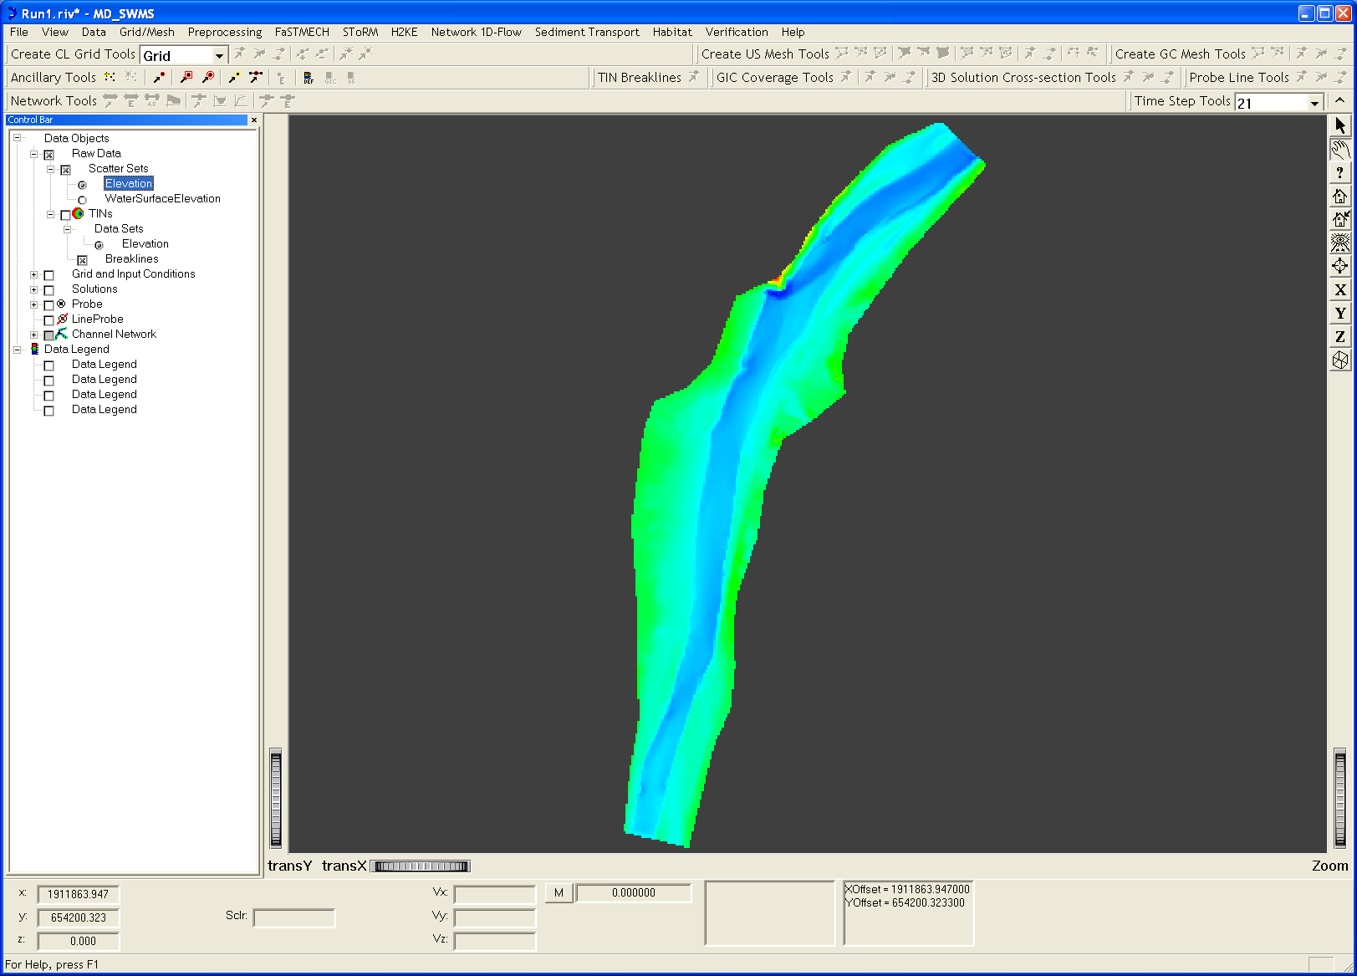

Figure 2.

Create the Computational Mesh

The computational domain is defined by a polygon that encompasses the area of interest. The steps necessary to create a mesh are:

- Use command Grid/Mesh | 2D Unstructured Mesh to select unstructured mesh mode.
- Turn on the Grid and Input Conditions in the Control Bar window at the left-hand side of the rendering canvas to activate the Create Mesh Tools buttons: .
- Use button to create the bounding polygon for the mesh. Note that no boundary points can be added later to this polygon, so it’s better to use too many than too few points (the location of these points can be edited later using button , which is activated by left-clicking Mesh Boundary in the Control Bar window).
- Input is ended by pressing <Return> on the keyboard.
- Right-click on Create Mesh (Control Bar window) to create the computational grid. Assign it a name (e.g., “meshT”).

The grid generator pop-up window that appears is used to specify the geometric constraints required by the mesh generator. They relate to mesh quality: maximum internal angle and maximum area of the triangles (Fig. 3). The first constraint avoids stretched triangles with poor interpolating properties. The second constraint defines their maximum size (the mesh generator will set the triangle size based on boundary conditions and on mesh smoothness and quality requirements).

- Enter the parameters shown in Fig. 3 and click the OK button to continue. Here, we use a maximum allowed triangle area of 7.5 m².
- The grid generator console (DOS window) will appear. Press the <Return> key on the keyboard after the mesh generation is done. For this set-up, a grid with 15,994 grid nodes and 31,251 triangles was generated (see Fig. 4).

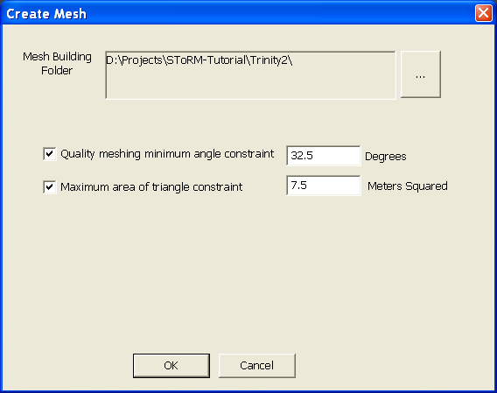

Figure 3.

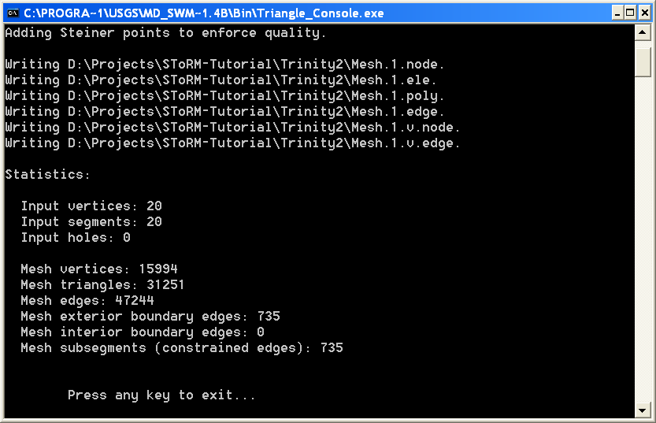

Figure 4.

- Map the elevation to the grid using Preprocessing | Set Current Input Conditions | Map w/TIN.

The computational mesh generated by the previous steps is shown in Fig. 4, after turning off Raw Data, Mesh Boundary, and Mesh Node Strings in the Control Bar window.

- Save your work (File | Save).

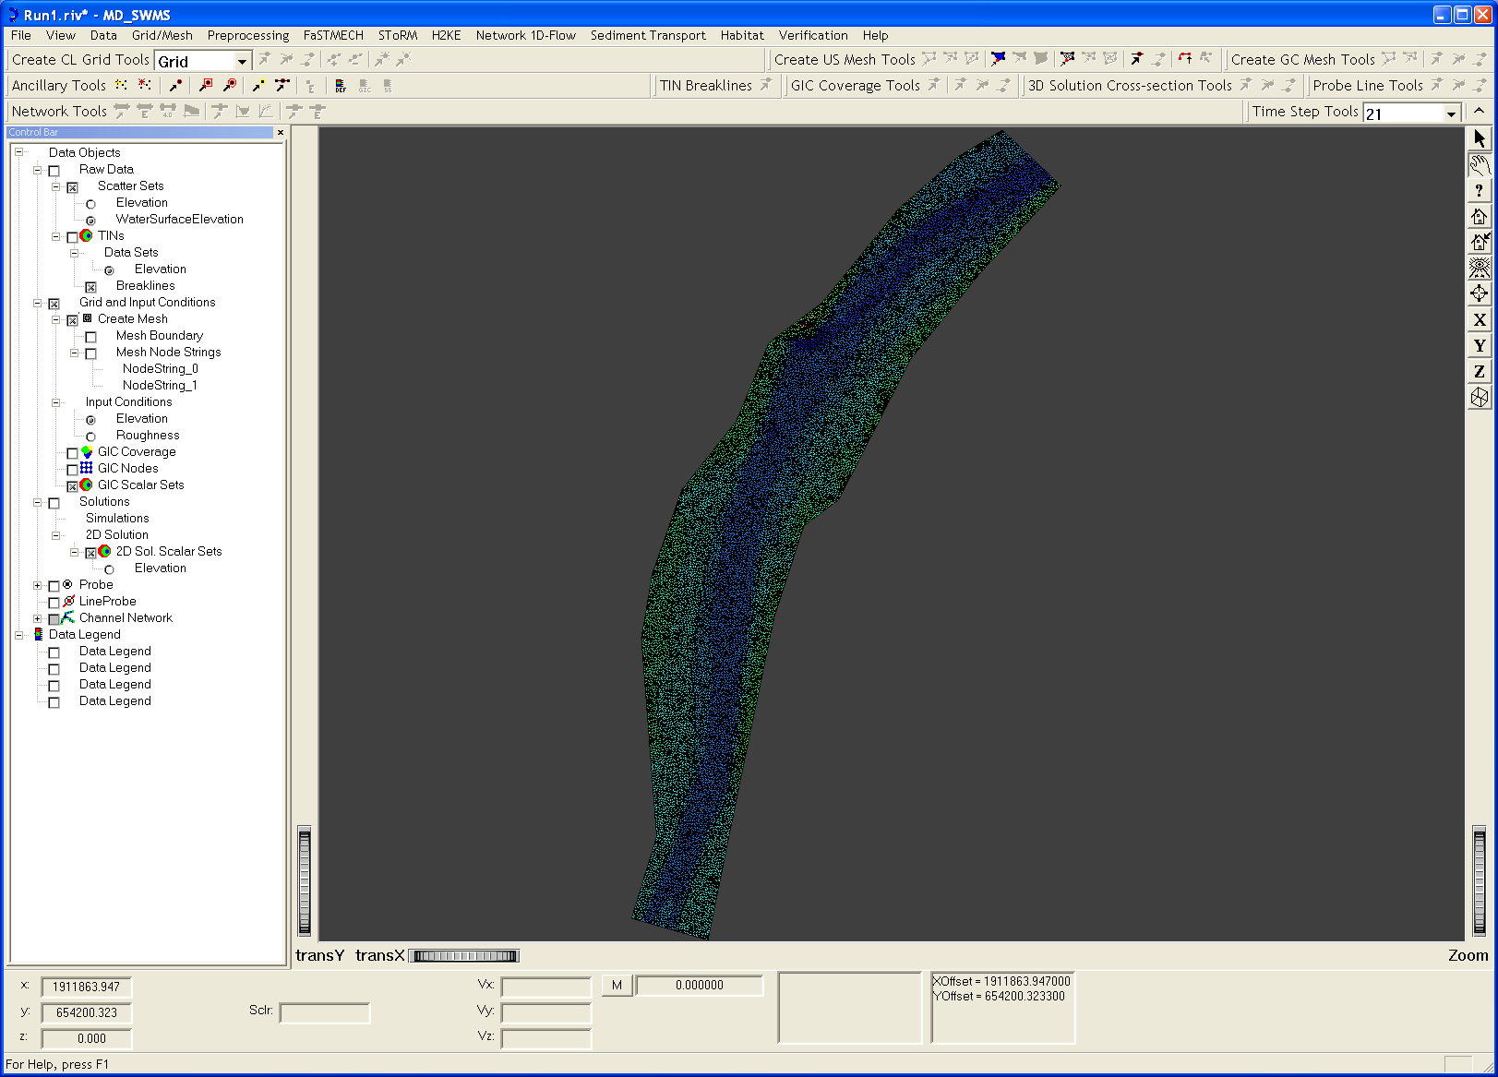

Figure 4.

Inflow and Outflow Boundaries

Now it’s time to define the inflow and outflow boundaries. In subcritical flow, the flow velocity must be specified at the inflow boundary and the stage at the outflow boundary. Each boundary is defined by creating a string of (adjacent) nodes using the button in the Create Mesh Tools toolbar. In this example, the inflow boundary is at the bottom and the outflow boundary at the top of the computational domain of Fig. 4. We are going to start by defining the inflow boundary and its associated parameters. It may be convenient to zoom in to the appropriate areas of the domain to have a more detailed view of the mesh, as shown in Fig. 6.

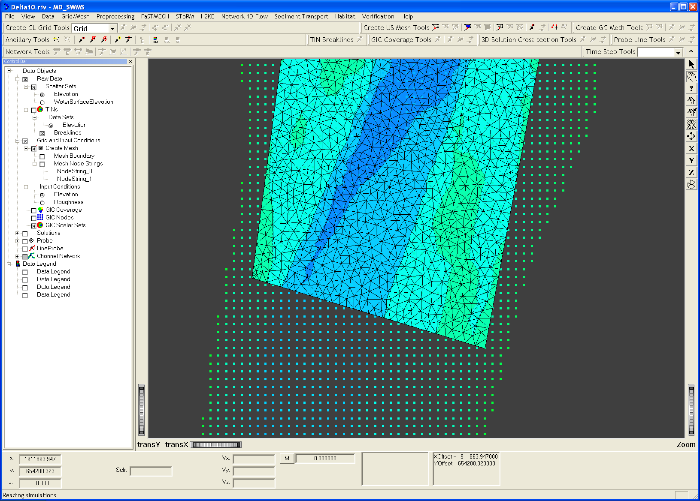

Figure 6.
- Click on and start at one end of the chain of nodes that are going to be the inflow nodes. Click on the first node and, without skipping any node, proceed clicking on all nodes along the boundary until the desired end is reached. Note that there is no need to click exactly at the node because the input tool “snaps” to the node nearest to the mouse pointer.
- Press <Enter> to end the string, which will now appear in the left Control Bar as NodeString_0. Fig. 7 shows how it all looks.

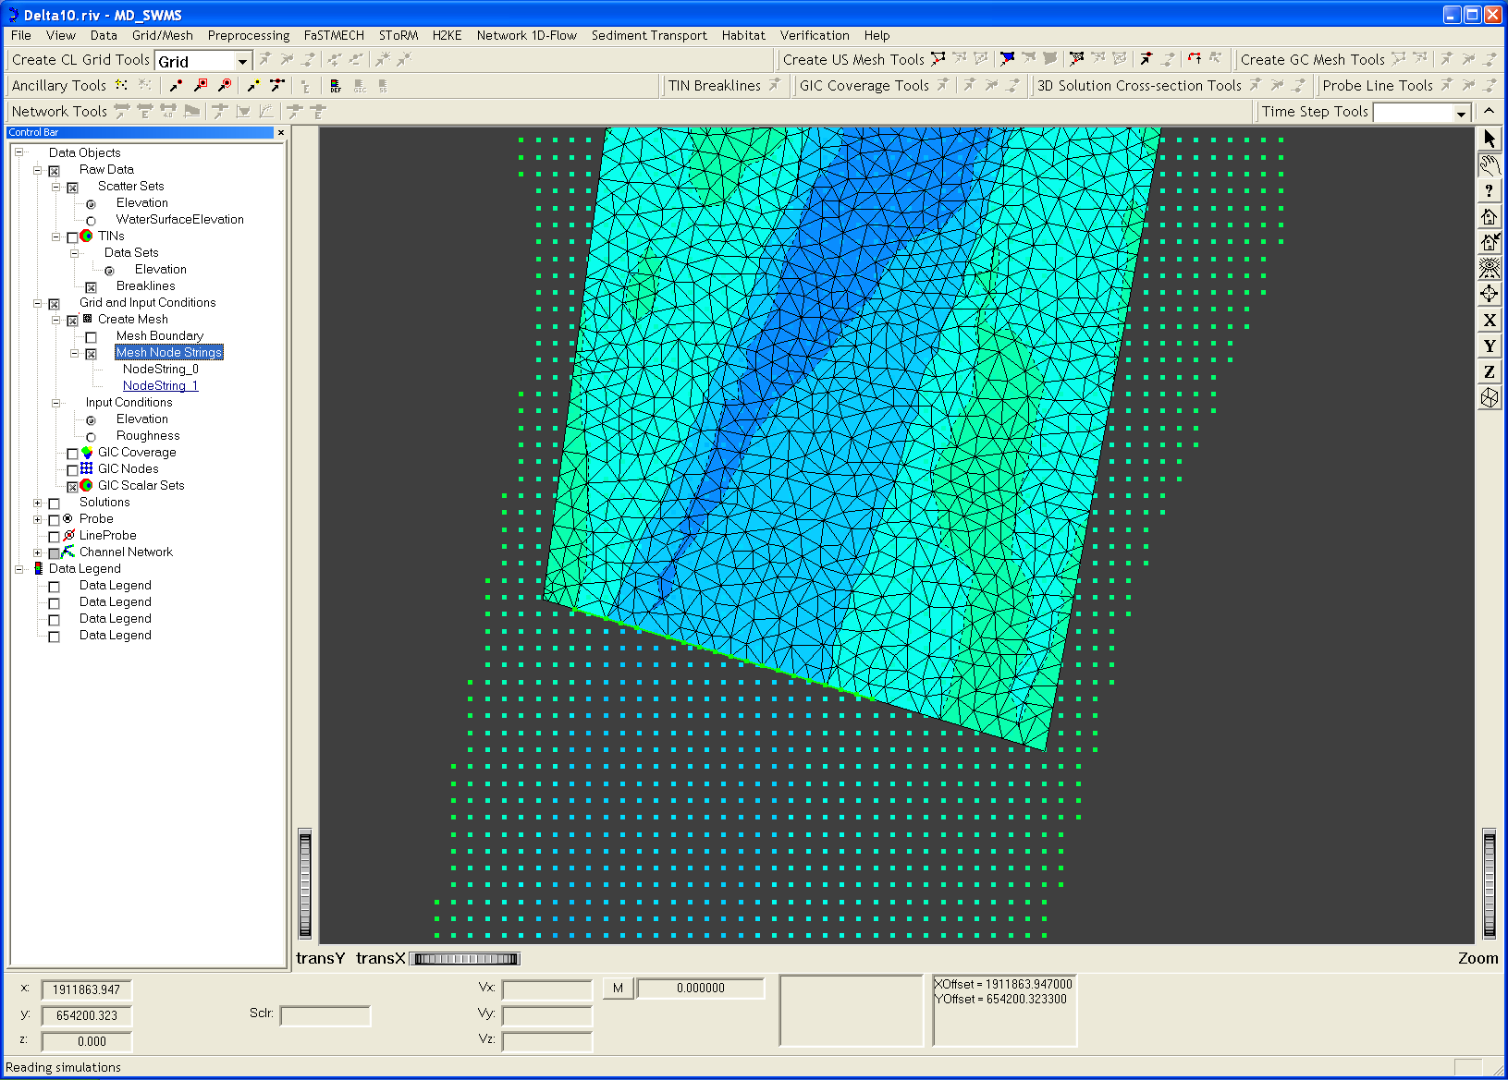

Figure 7.

- To define the type and values of the just constructed boundary, right-click the node string name in the Control Bar, which in this case appears as Grid and Input Conditions | Create Mesh | Mesh Node Strings | NodeString_0.
- Choose Assign Boundary Condition in the pop-up menu and define a steady inflow discharge of 113 m³/s (Fig. 8).

Note that all the parameters defined for model SToRM must be in SI units. The discharge used in this example (4,000 cfs) is in the high range of the regulated flows released by Lewinston Dam and is only seen in wetter years. The corresponding outflow stage can be obtained from the water surface ancillary data set, which can be probed using the button in the Ancillary Tools toolbar. First, pan the computational grid to the outlet boundary, where the string of nodes that form the outflow nodes is going to be specified

- On the Control Bar, click on Raw Data > Scatter Sets> WaterSurfaceElevation to view the data points (see Fig. 9).

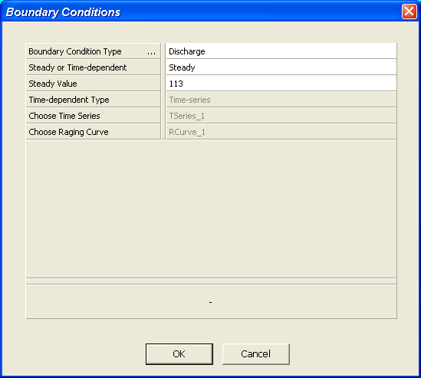

Figure 8.
- Click on and right-click on the appropriate data node. The corresponding value of the water surface elevation appears on a small area at the bottom of the main window.

For the grid defined for this tutorial example, the value is approximately 448.8 m. Just as when defining the inflow boundary, use button to create a new string of nodes. Don’t forget to press <Enter> to end the string. See Fig. 10 for the outflow boundary defined for this example.

The new string appears in the Control Bar window under Grid and Input Conditions | Create Mesh | Mesh Node Strings | NodeString_1.

- Right-click on it and choose Assign Boundary Condition to define the boundary type and value (Fig. 11).

Sometimes it is easy to make an error creating a boundary-node string. Any string can be deleted by right-clicking on its name and selecting Delete in the corresponding pop-up menu. In this case, a new boundary node string must be redefined again.

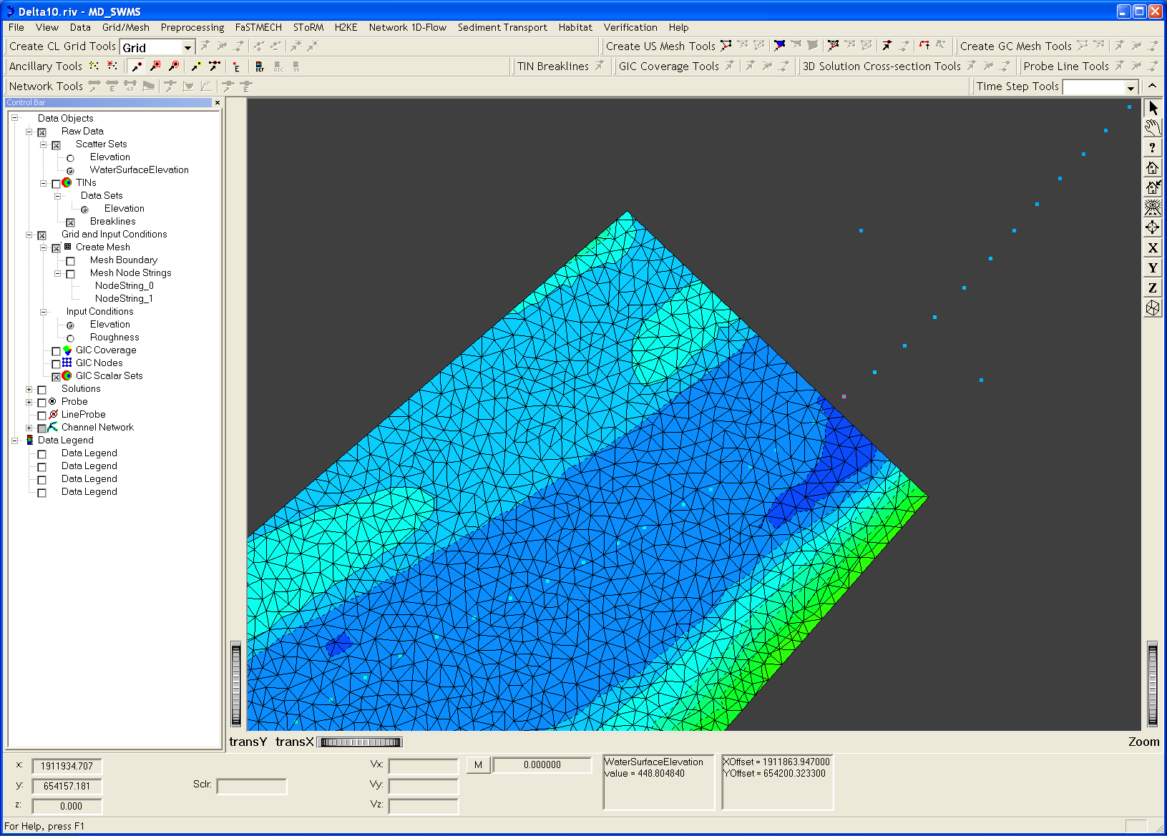

Figure 9.

The inflow and outflow node strings specified may or may not get wet (i.e., have a water depth greater than zero) during a particular simulation. They may get wet or dry (or go through any number of wet-dry cycles) depending on the boundary and on the initial conditions. Boundary nodes that are not defined as inflow or outflow nodes are treated as solid walls. The outflow stage is a boundary condition that is enforced, therefore the solution there can be accurately calculated. In this case, specifying a string of nodes that is too wide does not generally constitute a problem.

Flow across the inflow boundary is calculated from downstream stage and from specified discharge. Consequently, the rules determining if a control volume becomes wet or dry are more complex. In particular, if a triangle at the inflow boundary becomes wet, it seldom becomes dry again, even when the stage subsides. This is because there is inflow across its edges, and that triangle becomes dry again only when drainage out of it is greater that the inflow. This means that, once it gets wet, a mild sloped triangle at the boundary may never dry again. This may result in wide inflow cross-sections (and equivalent lower flow velocities) that may not be realistic. Therefore, it is advisable to define the inflow boundary away from the area where the simulation results need to be the most accurate. As a guideline, a few channel widths will generally be sufficient. Also try to define an inflow boundary that is as accurate as possible, i.e., one that does not expand exceedingly into the overbank area. To achieve this effectively, some trial-and-error may be required.

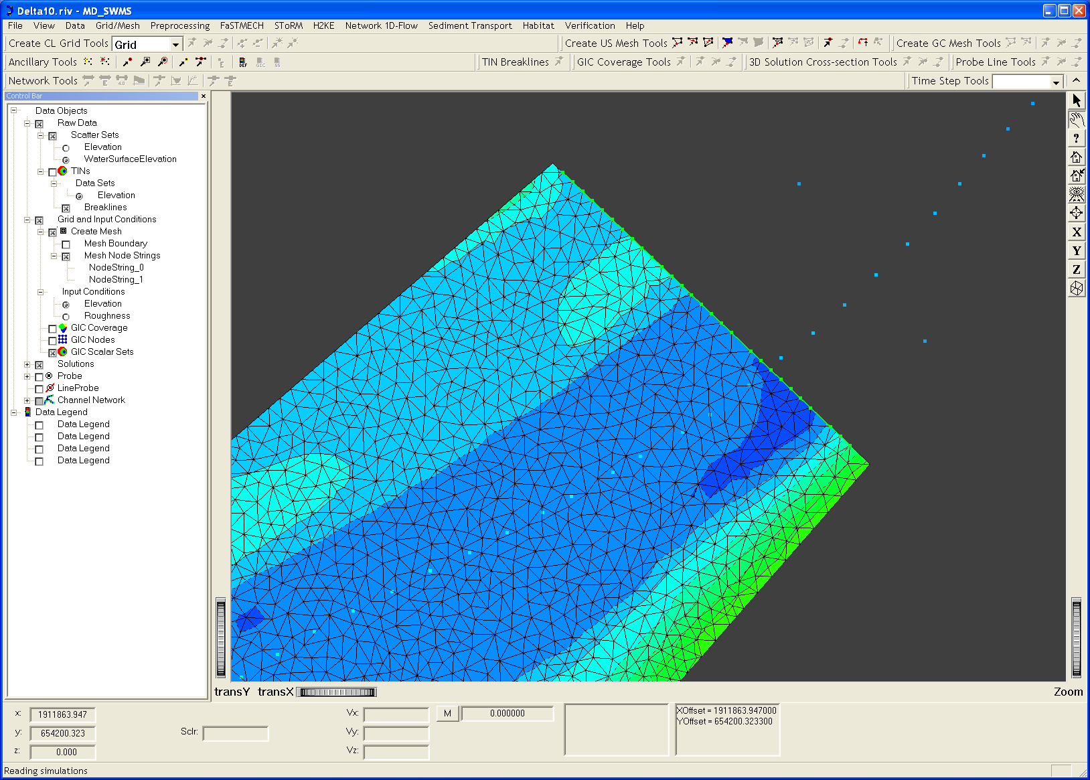

Figure 10.

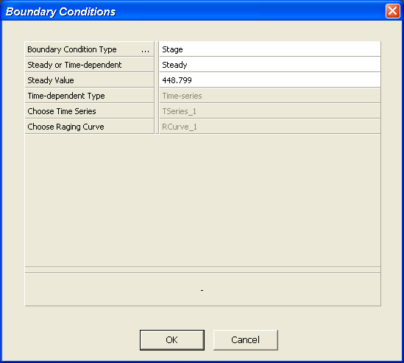

Figure 11.

Set value of the roughness. The Manning’s roughness model will be used in this tutorial.

- In the pull-down main menu bar choose Preprocessing | Set Roughness Input Condition | Set Constant and enter a value of 0.030 in the dialog, as in Fig. 12. As mentioned above, this is a Manning’s roughness value.
- Save your work (File | Save).

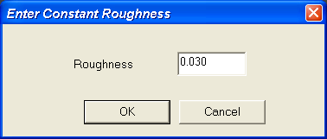

Figure 12.

Running the Model

To prepare a SToRM run, a “simulation” needs to be created. This allows the results of multiple runs to be displayed simultaneously within MD_SWMS. Each simulation will take a particular set of parameters and boundary conditions. These data sets are collected in a file which is used as input for program SToRM. The simulation is created from the main pull-down menu bar:

- Select SToRM | Create Simulation. It is necessary to specify a name for the run, which here we called TrinityA, and that will appear in the Control Bar window.

SToRM uses a number of parameters that must be specified by the user depending on the objectives for each run. This is done in the Storm Parameters window. To enter the parameters for run TrinityA created in the previous step:

- Select SToRM | Edit Input File from the main pull-down menu bar.

The Storm Parameters window has a different entry screens that are selected at the left-hand side panel. The first is titled Boundary Condition Properties. For this tutorial, the parameters chosen are shown below in Fig. 13.

- Bring-up the SToRM Parameters window from SToRM | Edit Input File and enter the values of Fig. 13.

The Roughness entry screen allows to define the type of roughness parameterization used, which is Manning’s. A turbulence model could have been selected in this screen, but in this example it is left out (Fig. 14).

- Click on Roughness and enter the values of Fig. 14.

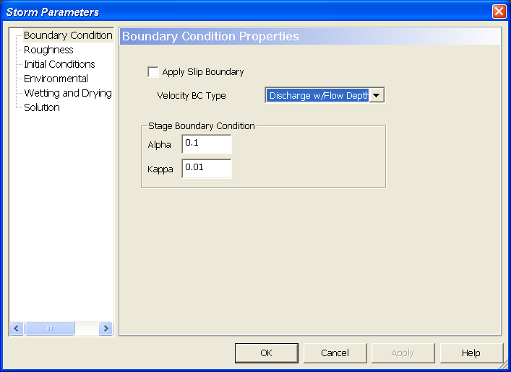

Figure 13.

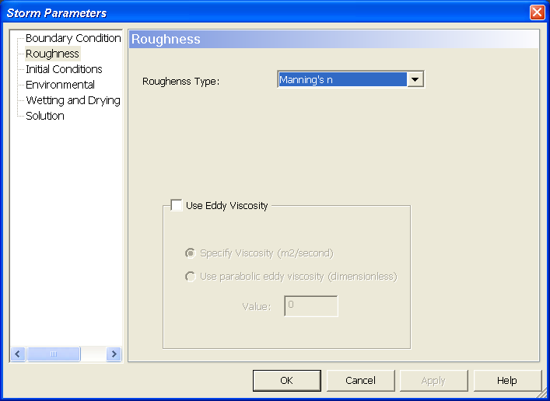

Figure 14.

The initial conditions (Fig. 15) are entered in the Initial Conditions screen. Initial values of the velocity along the x-direction (0.5 m/s), along the y-direction (1.8 m/s) and of the stage (449.5 m) are specified uniformly over the entire domain. Always make sure that the initial water surface elevation wets at least three or more of the inflow boundary nodes. In this example, the value of the stage is the average between the stage at the inflow and at the outflow boundaries.

- Click on Initial Conditions and enter the values of Fig. 15.

The Environmental entry screen (Fig. 16) is used to enter the water temperature, which in turn is used to compute the kinematic viscosity of water.

- Click on Environmental and enter the value of Fig. 16.

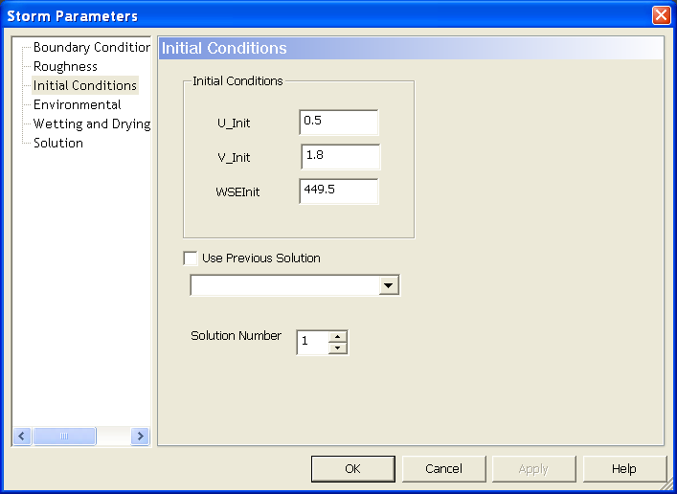

Figure 15.

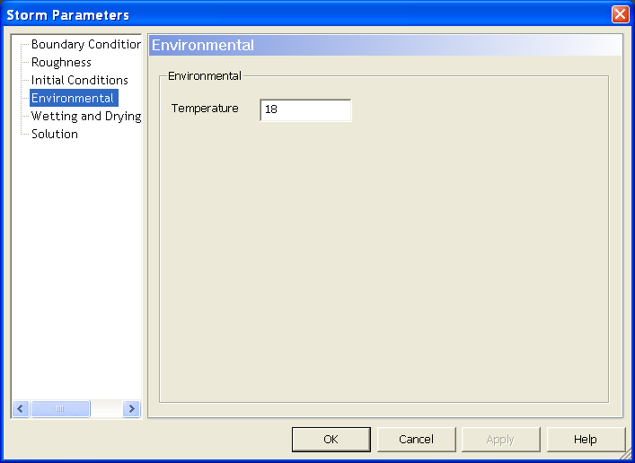

Figure 16.

The Wetting and Drying entry screen (Fig. 17) is used to enter a number of important parameters used by the SToRM algorithms that deal with wetting and drying. The first parameter (Threshold for dry cells) is a value of the water depth below which a wet cell becomes dry. In this case 5 mm is used as the value of the depth to dry a wet triangle. The second parameter (Threshold for wet cells) is used to determine a depth threshold above which a dry cell becomes wet. This value, multiplied by the Threshold for dry cells, determines that depth. In this case the value is 2, meaning that a dry cell is considered wetted when the water depth in it becomes larger than 10 mm (5 x 2 mm). This value, which is used to provide some hysteresis effects in the wetting and drying cycle, must be greater or equal to one. The third (Threshold for stagnant cells) parameter is not used by the current version of SToRM (version 0.3) and can be safely ignored. The last parameter (Threshold for shallow cells) is the value of the water depth below which a simplified overland flow algorithm is used (instead of the full 2D SWEs normally used by SToRM). In Fig. 17 we disable this algorithm by setting this parameter to a value lower than the Threshold for dry cells.

- Click on Wetting and Drying and enter the values of Fig. 17.

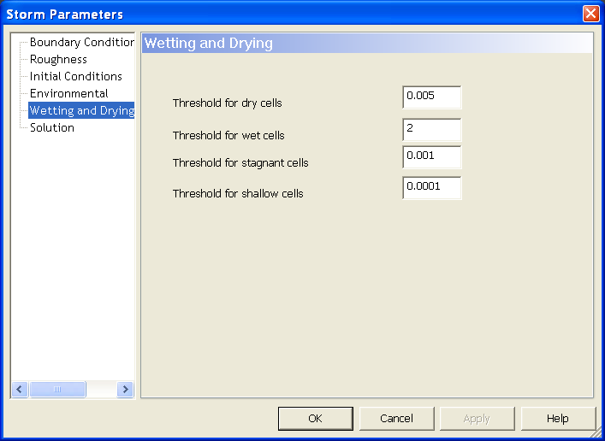

Figure 17.

The last screen is, perhaps, the most complex one: the Solution entry screen of Fig. 18. In this tutorial, an unsteady run is requested (check in Time stepping solution) with manual time step size (unchecked Automatic Time-Step), in which case the value in the Courant Number box corresponds to the physical time step (set to 0.05 s). The first-order time marching scheme is used (Order 1 in the pull-down menu Time Stepping Method) and the maximum number of time steps allowed (Maximum Iteration) is 200,000, corresponding to a physical time of 0.05 x 200,000 = 10,000 seconds (approximately 2 hours and 47 minutes). The alternate stopping criterion chosen is based of the relative change in water depth from one time step to another (Water Depth Rel in the Stopping Criterion pull-down menu), which is set to 0.000001. This means that SToRM will stop when the relative change in water depth from one time step to the next is smaller than this value. The solution will be stored every 10,000 iterations for later review and analysis, set in the Plot Increment window.

Solution gradients are computed using a second-order method without limiters (No Limiter in the Gradient Reconstruction Limiter pull-down menu). This method is adequate for the usual flows encountered in large rivers, but may result in solutions with spurious oscillations in flows with sharp gradients of the flow variables, such as those encountered across hydraulic jumps. The High-order Gradient Reconstruction option is left unchecked to speed-up the computations and the trigger for activation of the shock-capturing computation method in SToRM is set at 10% (0.10 in the Shock Capturing Threshold window).

- Click on Solution and enter the values of Fig. 18.

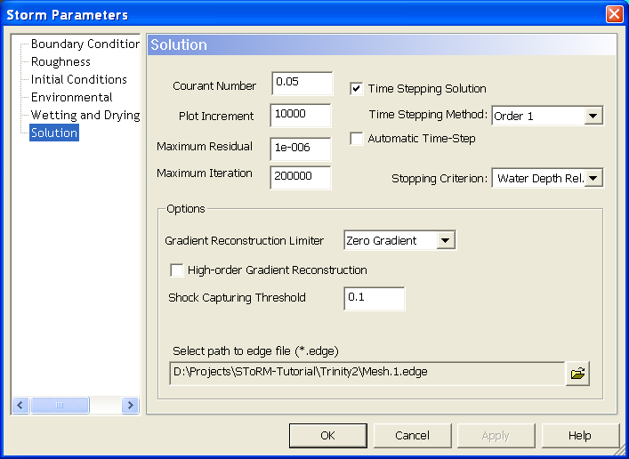

Figure 18.

With all the parameters thus chosen, from the main pull-down menu bar select SToRM | Run. This will launch SToRM with the parameters defined above and will show the run’s progress (Fig. 19). A DOS window will pop-up where the progress of the computation can be followed. In the first column appears the iteration number, the second column contains the corresponding time (seconds), the third column contains the value of the quantity selected for the stopping criterion (residual or rms error of the velocity), and finally the total volume of water (m³). Note: for steady state runs the second column is omitted.

- Save your work (File | Save).
- Run SToRM from the main pull-down menu SToRM | Run.

Visualization of Results

Below are a few views of the results of this simulation. The water depth at approximately the midway point of the simulated reach is shown in Fig. 19 after appropriate panning and zooming.

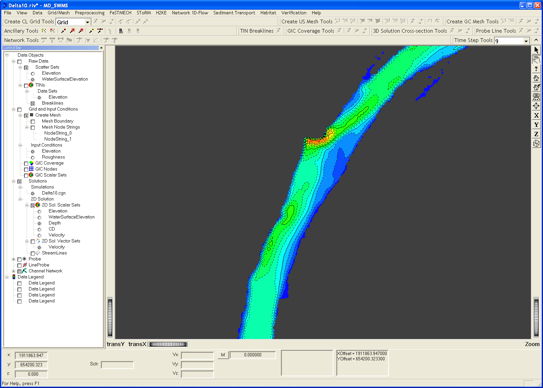

Figure 19.

The parameters governing the size and appearance of the velocity vectors have inconvenient values for viewing the solution.

- Double-click on Solutions | 2D Solution | 2D Sol. Vector Sets to bring up the Vector Attributes menu and change those parameters (see Fig. 20). Now, the flow field can be viewed with more convenient velocity vectors (Fig. 21).

Streamlines can also be best viewed with some alteration of their initial plotting parameters.

- Double-click on Solutions | 2D Solution | StreamLines to bring up the Stream Line Attributes menu and set the parameters as shown in Fig. 22.
- Select WaterSurfaceElevation in the 2D Sol. Scalar Sets.
- Fig. 23 shows how the flow looks like after zooming out to a larger area.

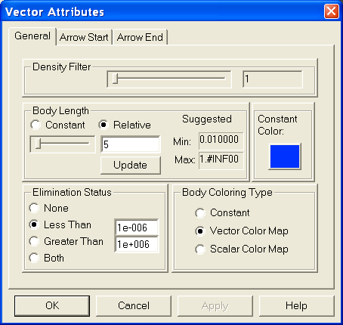

Figure 20.

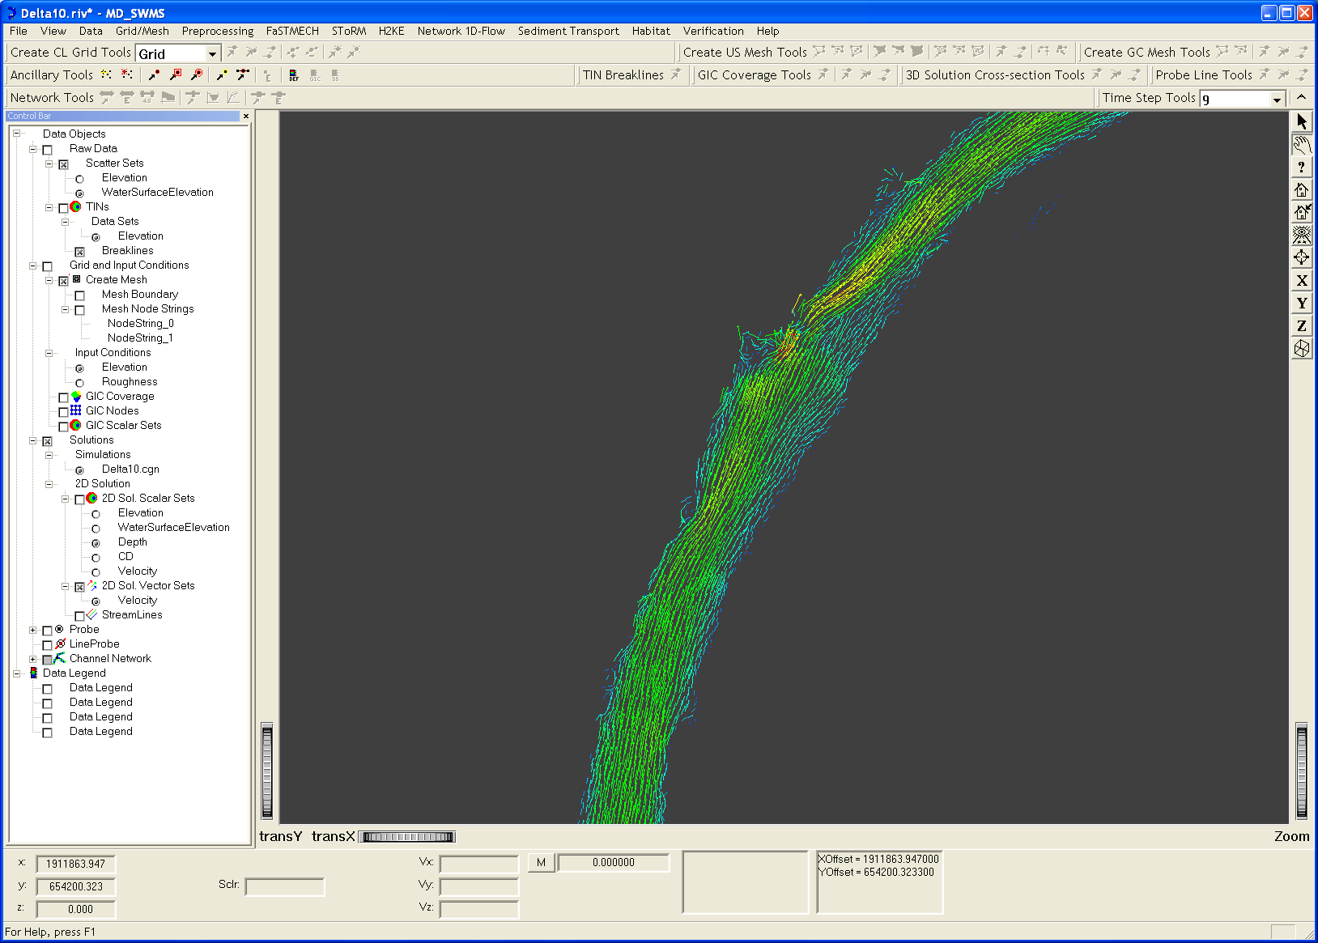

Figure 21.

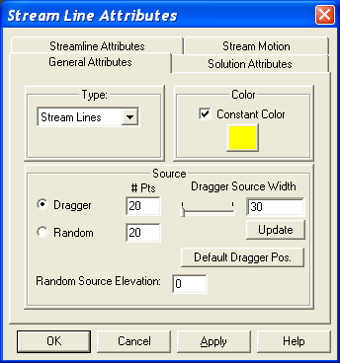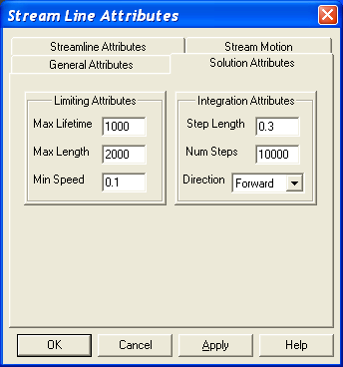

Figure 22.

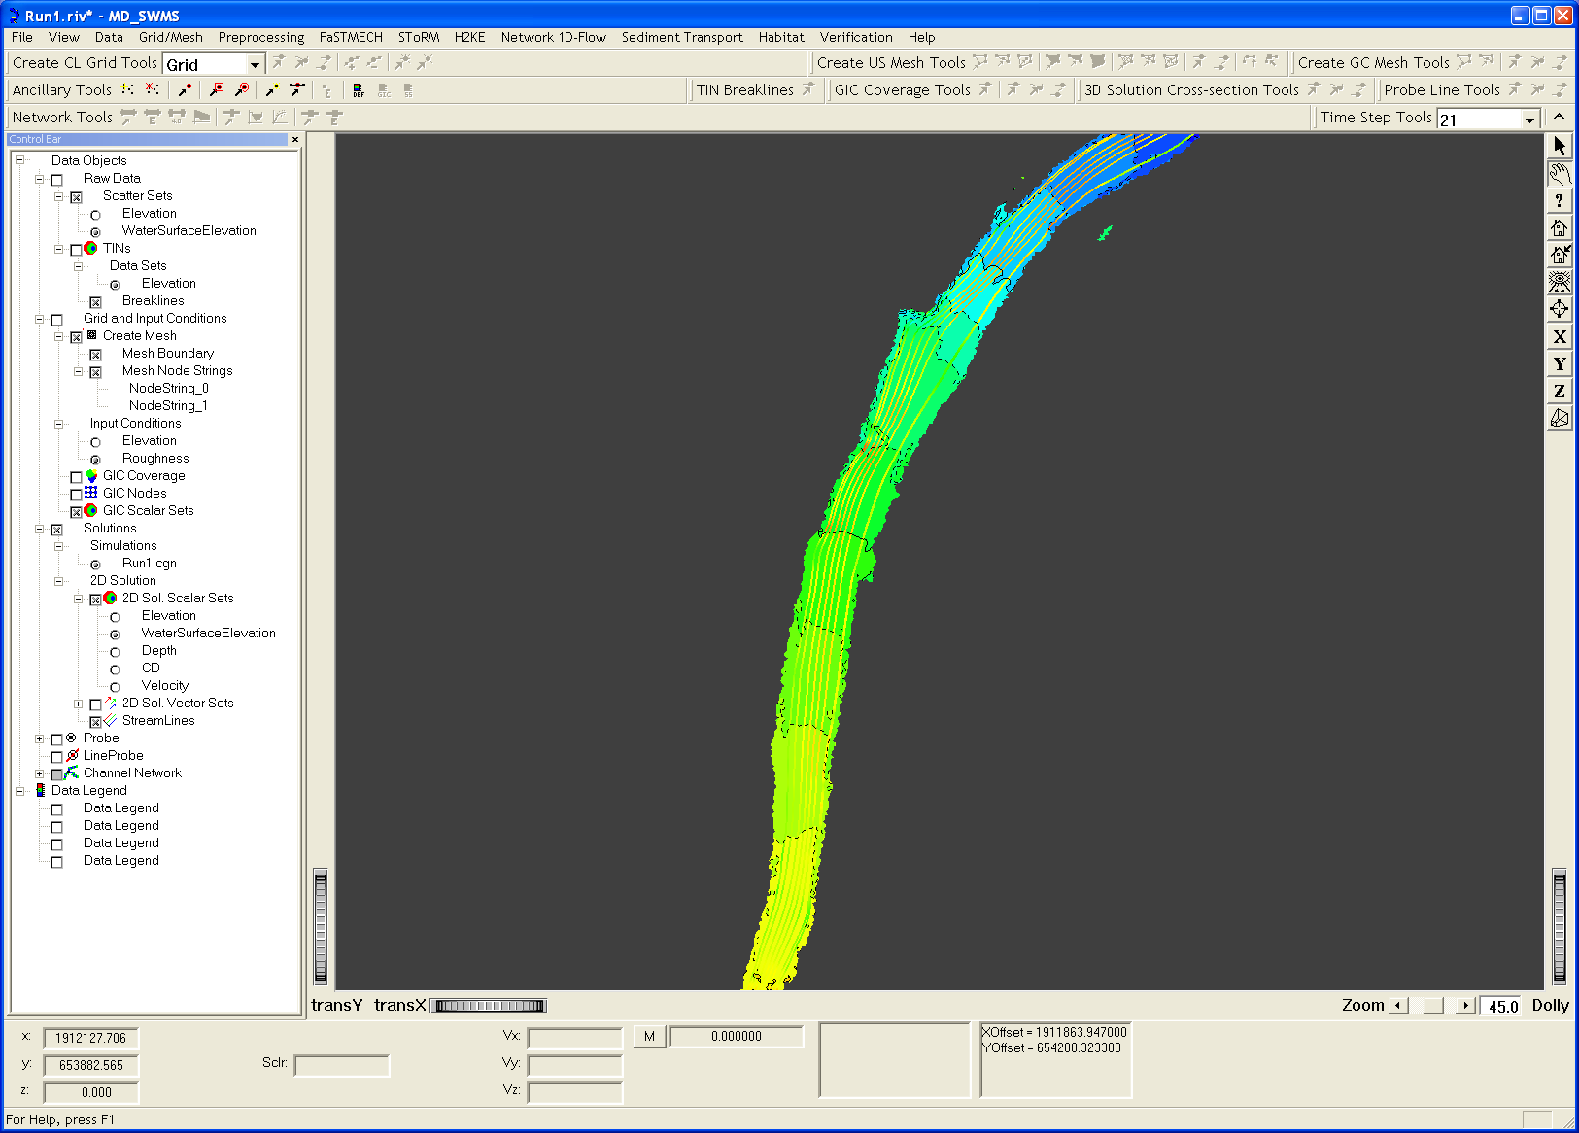

Figure 23.

To look at the convergence history of the run, bring up the Convergence window:

- Use the pull-down command SToRM | View Convergence. The resulting pop-up window is shown in Fig. 24.

The convergence history shows two important things. Firstly, it shows if the results of the simulation have converged to steady state. The rms of the change in water depth shown in Fig. 24 shows that a platform has been reached to a tolerance of 10⁻⁵. The fluctuations shown are normal and their magnitude is acceptable, remaining in the same order of magnitude (10⁻⁵).

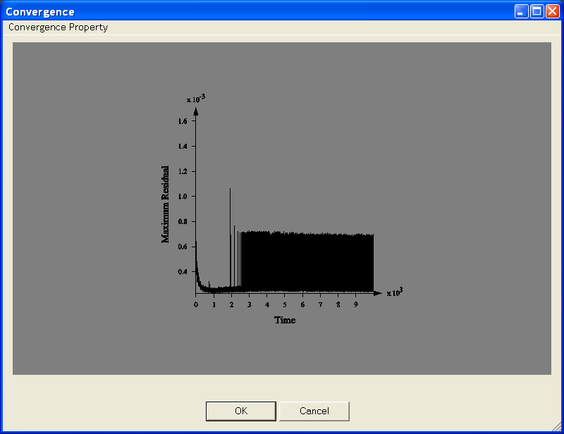

Figure 24.

To confirm that steady state has been reached, we need to look at the other convergence indicator available in MD_SWMS.

- Click on Covergence Property pull-down menu at the top right corner of the Convergence window and select Total Mass. The result is shown in Fig. 25.

This indicator gives the history of the total mass (or volume) of water in the computational domain. In Fig. 25 it is clear that a platform has been reached, further confirming that the solution has converged to steady state.

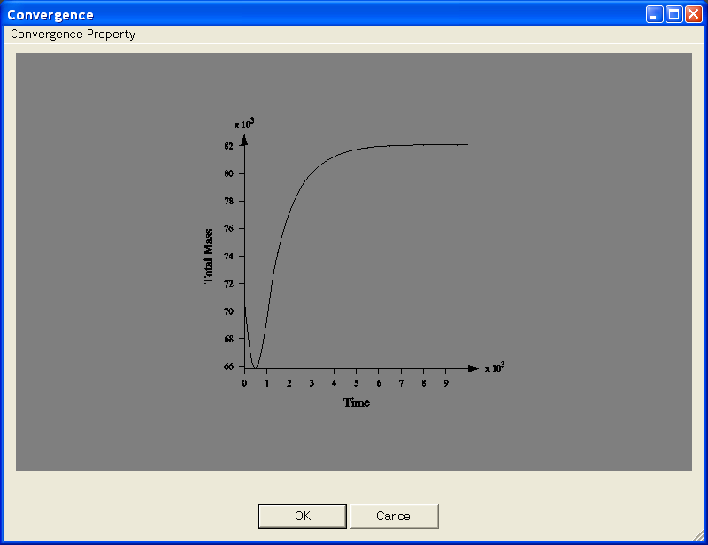

Figure 25.

The second aspect disclosed by the convergence history is the approximate time in the calculations at which steady state was reached. Form Fig. 25, it can bee seen that steady state was reached in the first half of the run, indicating that the 200,000 time steps used (see Fig. 18) constitute an unnecessarily long run. Future runs of this case can be done in, perhaps, half that time.

MD_SWMS provides tools to help calibrate model parameters. Model calibration is important to ensure that the model results are consistent with the physical prototype. In particular, roughness is often an unknown parameter. Roughness is difficult to determine in loco and usually is determined from indirect measurements. In this case, there are water surface elevation measurements for the discharge used. These measurements were loaded into MD_SWMS as ancillary data to determine the value of the water surface elevation at the outflow boundary. The same data can be used to find the right value of the Manning’s n by doing several runs with different values of n. Comparison between measurements and simulation is done using the pull-down command Verification | WS Verification:

- Click on Verification | WS Verification to bring up the Verification pop-up window.

Issuing the above command brings up the Verification window, which, for the data and parameters used in this tutorial, looks like the window displayed in Fig. 26. Finding the optimal value for the roughness requires a trial-and-error procedure. In some cases it may also require the use of spatially variable roughness coefficients.

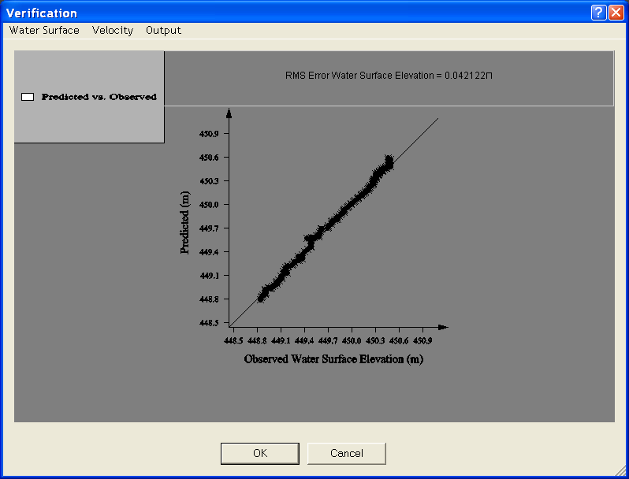

Figure 26.

An idea about the accuracy of the previous results can be obtained by repeating the run using the same grid with a more accurate numerical technique. Here, a run with gradient reconstruction using No Limiter and Higher-order Gradient Reconstruction will be used, as shown in Fig. 27. It may be helpful to compare the parameters used here with those used in the previous run, shown in Fig. 18.

- Bring up the Storm Parameters window using command SToRM | Edit Input File in the main pull-down menu.
- Edit the Solution entry screen to match the parameters shown in Fig. 27.
- Save your work (File | Save).
- Run SToRM (SToRM | Run).

The results are shown in Fig. 28.

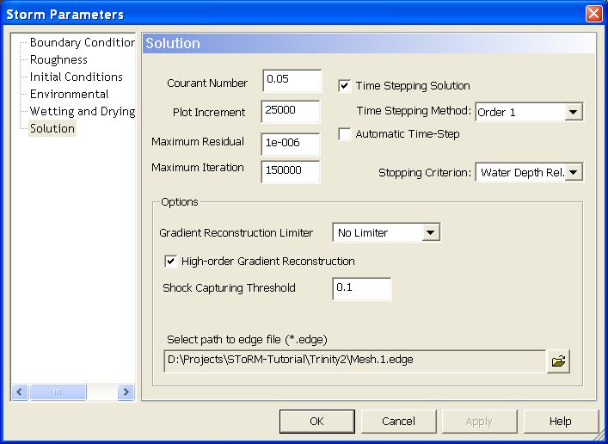

Figure 27.

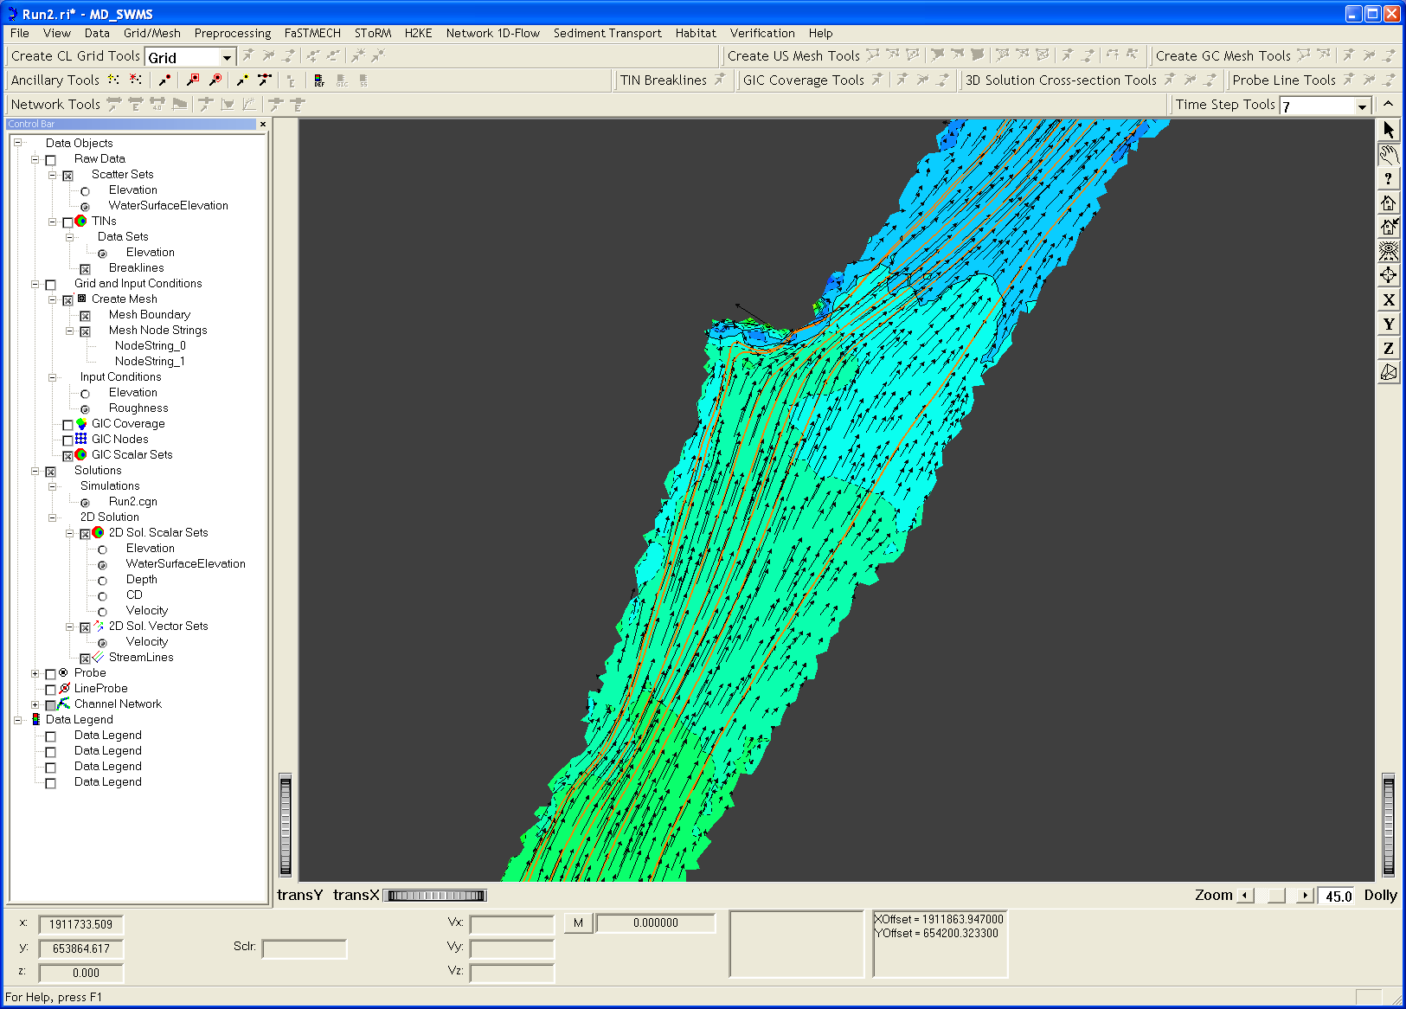

Figure 28.

Upon careful analysis, it can be concluded that there aren’t significant differences between these and the previous results, indicating that some convergence has been obtained for the current computational grid. Further analysis could be carried by doing selective mesh refinement and coarsening.

Because some important parameters have changed, especially those selecting different numerical solution methods, it is important re-establish that converged solutions were obtained.

- Use the pull-down command SToRM | View Convergence to bring up the convergence history display window.

The resulting plots are shown below (rms of the change in water depth in Fig. 29 and the total mass in the computational domain in Fig. 30), indicating that steady state solutions have been obtained.

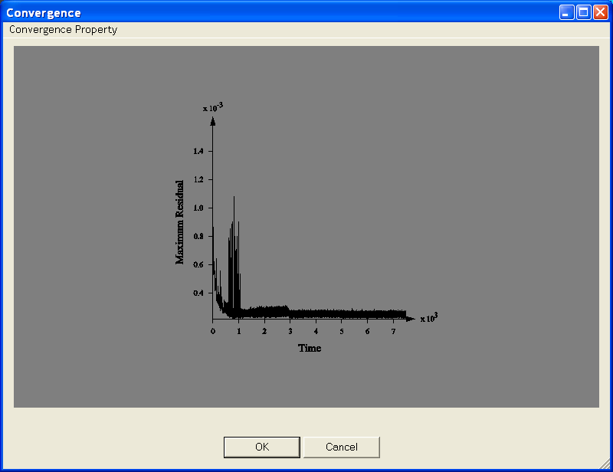

Figure 29.

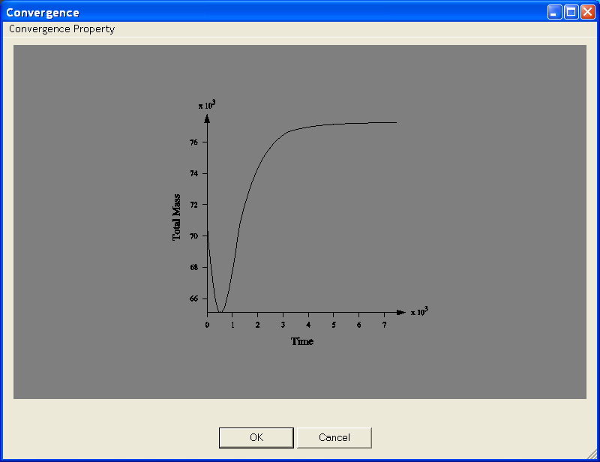

Figure 30.

It is also necessary to check that the model remains calibrated for the case at hand.

- Click on Verification | WS Verification to bring up the Verification pop-up window.

The plot showing the comparison between simulation and measurements of water surface elevation is shown in Fig. 31, indicating good agreement. Comparing with Fig. 26 it is possible to see that there are some changes in the middle of the reach.

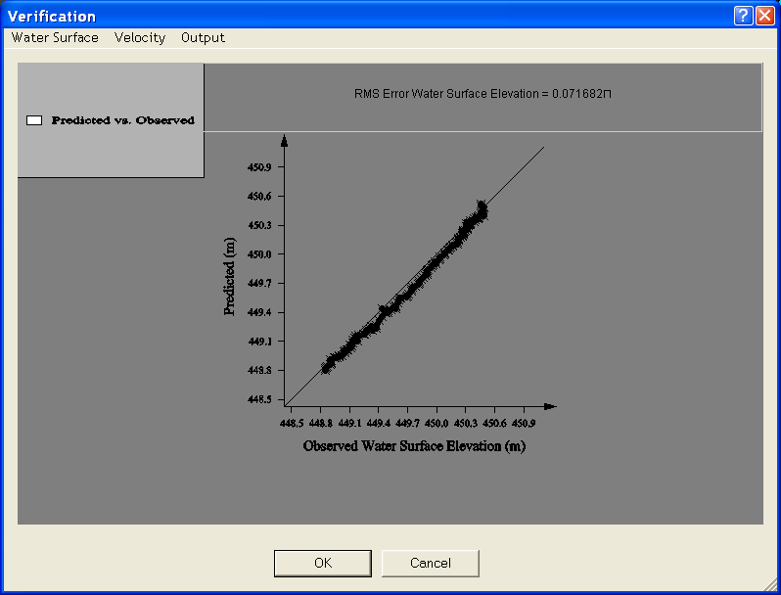

Figure 31.

Using Unsteady Boundary Conditions

It is possible to run SToRM with variable boundary conditions. In this section, it is shown how to set up and execute a model run using an inflow boundary with variable discharge. Below, the following steps are going to be carried out:

- Start a new SToRM project. This will allow us to store the new unsteady solution in a different .cgn file.
- Define the desired variable inflow boundary condition.
- Use the steady state solution obtained in the previous run in this tutorial as a starting point for the new run.
- Run StoRM.
- View the results.

To accomplish step #1, we can simply save the current MD_SWMS project in a new file:

- Use command File | Save As… to save the current MD_SWMS project with a new name (say, lets call it Run3.riv).
- Create a new solution with command SToRM | Create Simulation and assign it a new name (Run3.cgn, for example).

As a result of the above commands, there will be a new solution file in the Control Bar window, under the tree Solutions | Simulations, as seen in Fig. 32 below. Note that the new solution file Run3.cgn is selected, indicating that that is the location used to store the new simulation results.

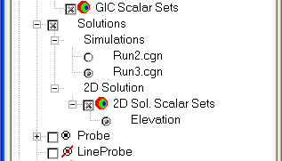

Figure 32.

Now, it is necessary to define the inflow boundary condition. First, we need the inflow hydrograph. The best way to do this is to define it in a standard ASCII text file. This file contains pairs of time and discharge, one per line, that will be read-in by MD_SWMS. For the present example, we will use the data in file Hydrograph1.txt, which looks like this:

0 113.4
1 114.0
2 115.2
3 118.0
4 124.0
5 136.4
6 158.7
7 191.0
8 225.3
9 252.0
10 268.0
11 276.1
12 280.0

This hydrograph is plotted in Fig. 33. It shows the discharge increasing from 113.4 m³/s (400 ft³/s) at time zero (in SToRM, the calculations always start at time zero) to 280 m³/s (10,000 ft³/s) in 12 seconds. This is a very sharp increase, such as what could be produced by a sudden dam break. It is only used here for illustrative purposes.

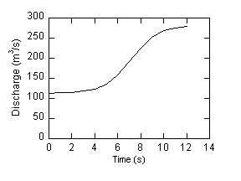
Figure 33.

The values used to prescribe the hydrograph are independent of the time step used later in the run. SToRM will interpolate linearly the values of the discharge in the intervals between the times used. For times greater than 12 seconds, SToRM will use the last discharge prescribed, which in this case is 280 m³/s. Similarly, the hydrograph does not need to start at time zero, in which case SToRM will use the first value of the discharge in the hydrograph.

It is now necessary to import the hydrograph into MD_SWMS:
- Execute command Preprocessing | Define Time-Series Boundary Condition to set up the variable inflow discharge. Fig. 34 shows the default screen.

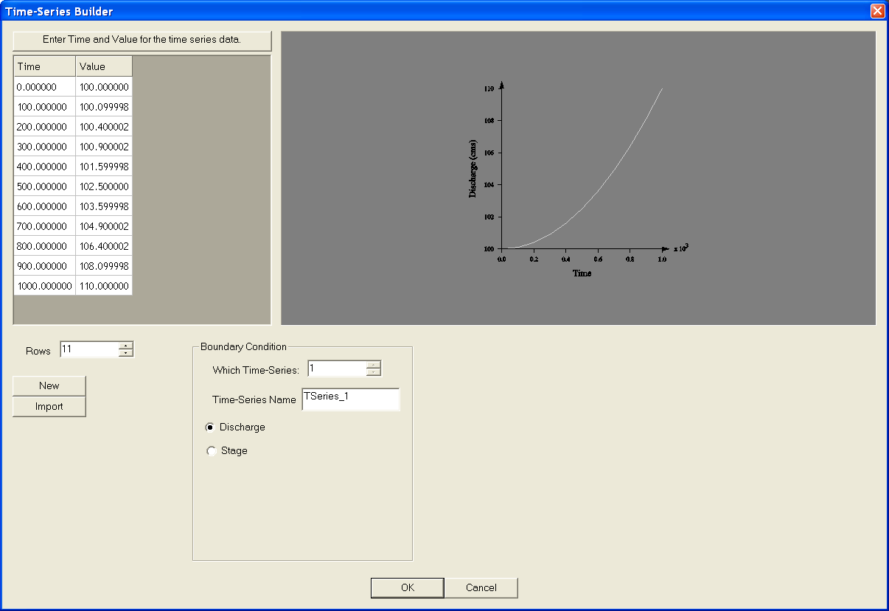

Figure 34.

- Import Hydrograph1.txt to TSeries_1 by clicking on the Import button and choosing the appropriate file name. The result is shown in Fig. 35.

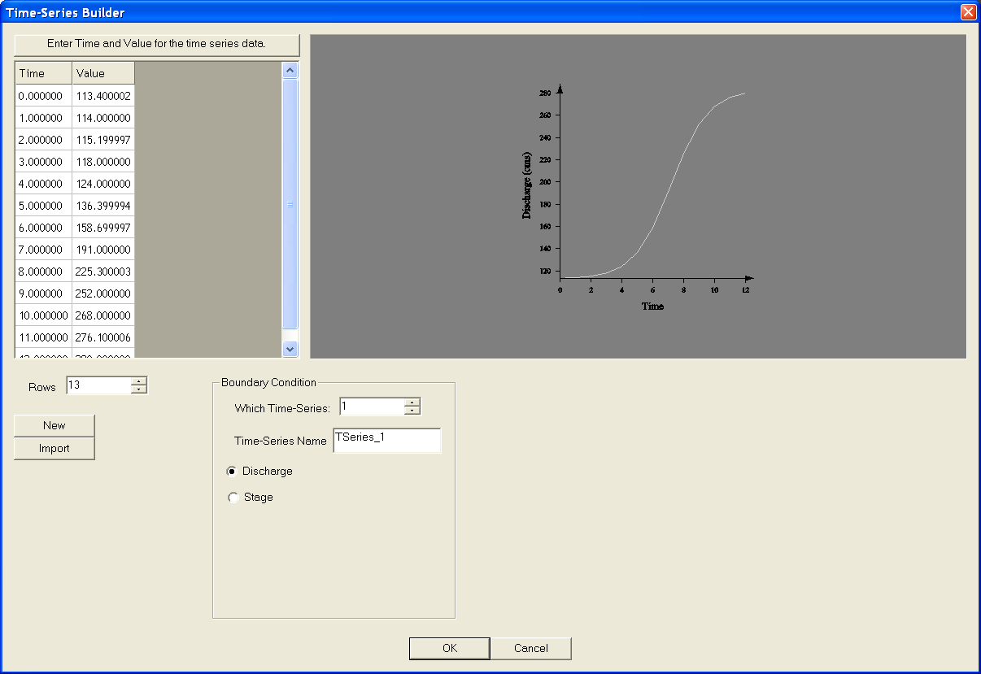

Figure 35.

Note that the values of the hydrograph are shown in the window at left, and that they are plotted at in the window at the right.

MD_SWMS allows the user to work with multiple hydrographs at the same time. To illustrate this process, we are now going to import a second hydrograph:

- Click on the New button. TSeries_2 will appear in the TimeSeries Name window and the counter in the Which Time-Series window is advanced to 2.
- Click on the Import button and select Hydrograph2.txt.

The new hydrograph is now shown, as displayed in Fig. 36. Both hydrographs can be displayed by incrementing (or decrementing) appropriately the value in the Wich Time-Series window.

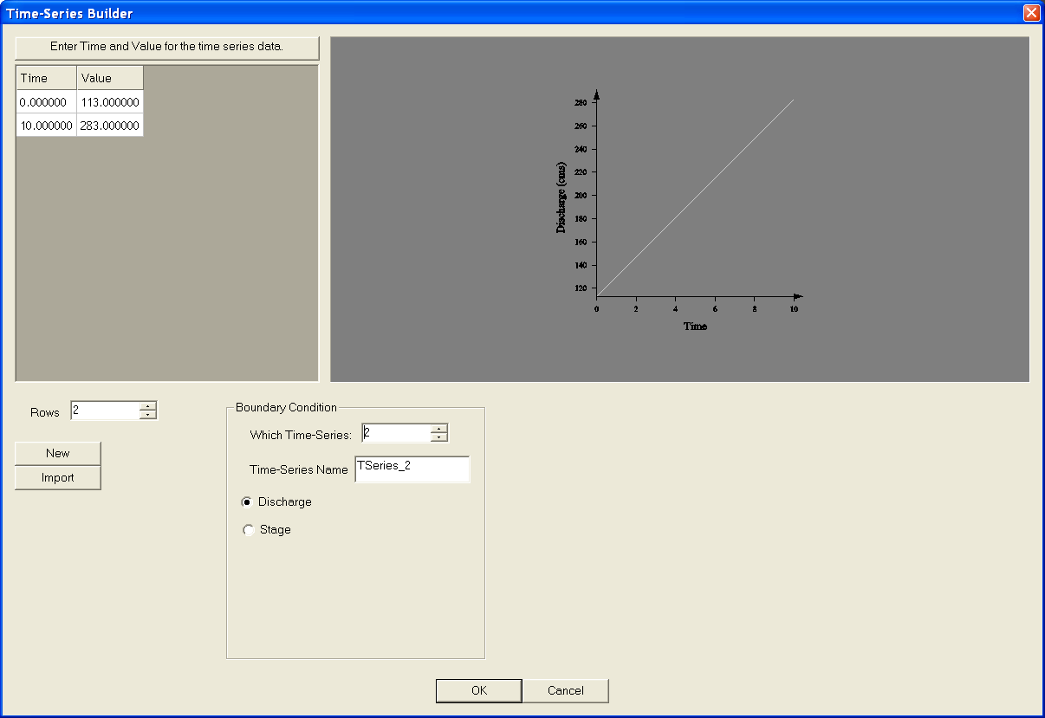

Figure 36.

- Click the OK button to close the window.
- Save your work (File | Save).

It is now necessary to assign the desired hydrograph to the inflow boundary. The inflow boundary has been defined in a previous section as the Nodestring_0 boundary (in the Control Bar window).

- Right-click on the string Nodestring_0 and select Assign Boundary Condition in the pop-up menu.
- Select Time-dependent inflow in the Steady or Time-dependent entry (click on this entry), in the pop-up menu that appears when clicking on the button, as shown in Fig. 37.

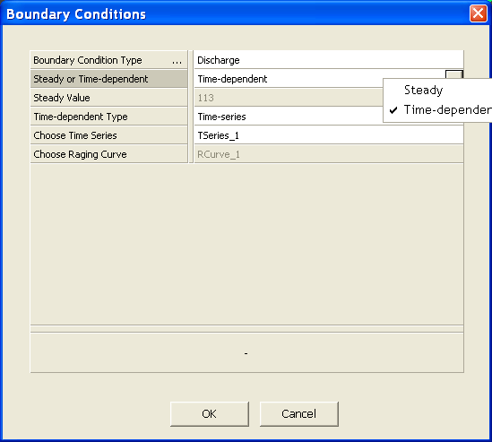

Figure 37.

Upon selecting the time-dependent option, the Time-dependent Type and the Choose Time Series entries become available for use.

- Click on Time-dependent Type.
- Click on the button and select Time-series in the pop-up menu (Fig. 38).

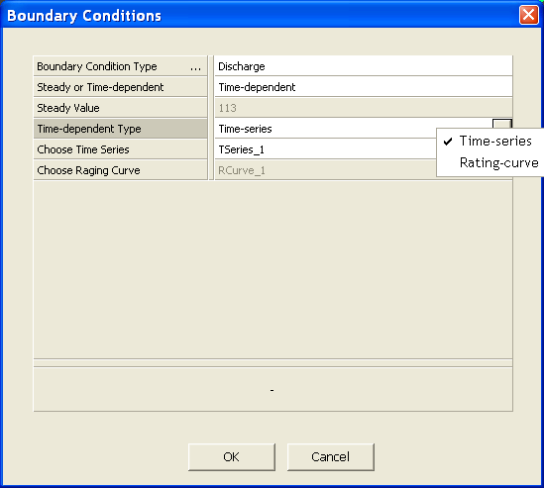

Figure 38.

Now select the appropriate hydrograph:

- Click on Choose Time Series.
- Click on the button and select Tseries_1 in the pop-up menu (Fig. 39).
- Click on the OK button to accept the new inflow boundary condition.

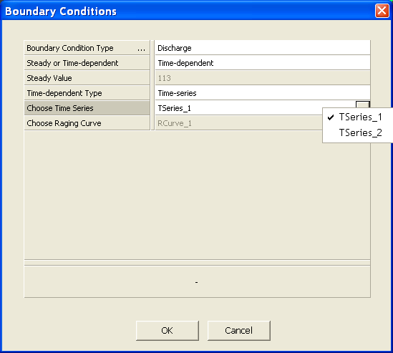

Figure 39.

We want to use the existing solution stored in Run2.cgn as the starting point of the new simulation. That can be done in the SToRM Parameters window as follows:

- Click on the SToRM | Edit Input File pull-down menu. To bring-up the SToRM Parameters window.
- Select the Initial Conditions window by clicking on the Initial Conditions label at its left window.
- Check Use Previous Solution and select Run2.cgn in the pull-down menu.
- Select 7 in the Solution Number window, because this is the last saved solution in the Run2.cgn file, as determined in the run of the previous section.
- The Initial Conditions entry window will look like the window displayed in Fig. 40.

We are going to do a run similar to the one accomplished in the previous section. Navigate through the remaining entry windows and make sure that they are right: the Boundary Conditions must look like the one displayed in Fig. 13; the Roughness like the one in Fig. 14; the Environmental like the one in Fig. 16; and the Wetting and Drying like the one in Fig. 17.

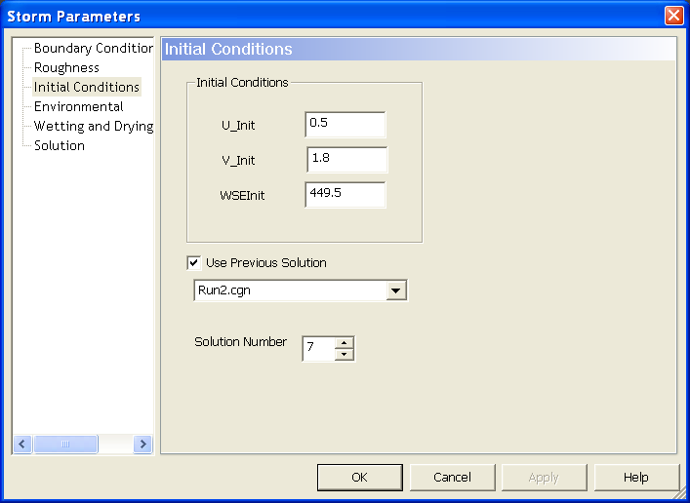

Figure 40.

Some changes must be done to the Solution screen of Fig. 27. We want to see how the flood wave propagates through the computational domain. We want to see it in intervals of 100 seconds. For a time step of 0.05 seconds, this requires saving the solution every 2,000 time steps, as shown in the Plot Increment window of Fig. 41. The run will take 1,100 seconds (just over 18 minutes), which is enough to see the wave travelling through the entire reach. This corresponds to 22,000 time steps in the Maximum Iteration window.

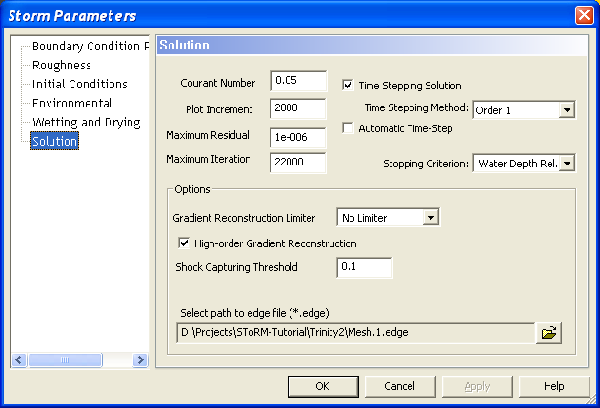

Figure 41.

Now save the project and run SToRM:

- Click on File | Save to save the project status.
- Click on the SToRM | Run pull-down menu to run the model.

After the run is complete, the results of the simulation can be seen selectively using the Time Step Tools pull-down menu. The results showing the water surface elevation at the different time steps requested in the Plot Increment option of Fig. 41 are presented in the figures below.

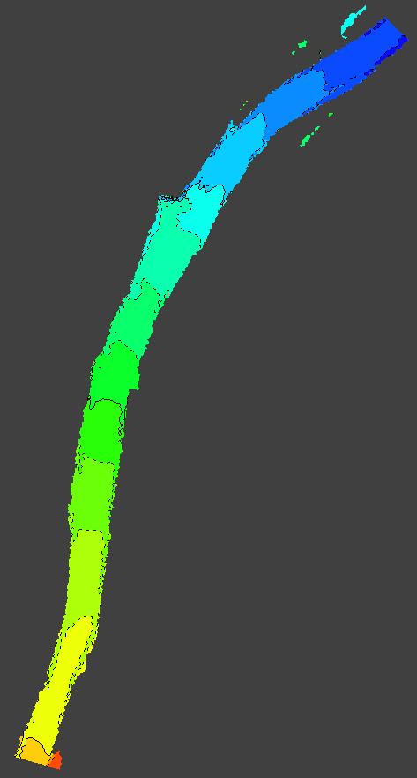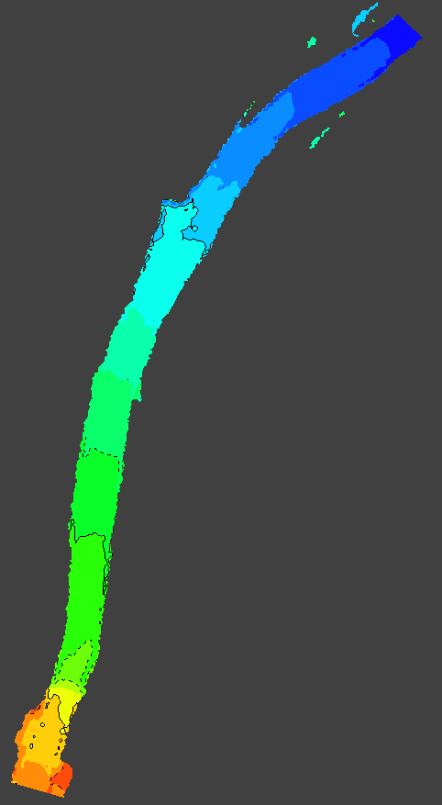

Figure 42. Initial conditions from the run of the previous section (left) and results after 2,000 time steps (right).

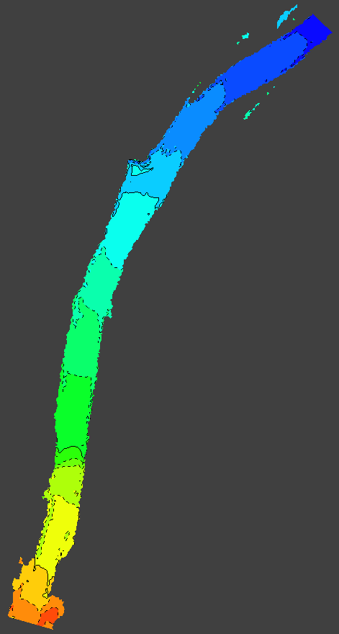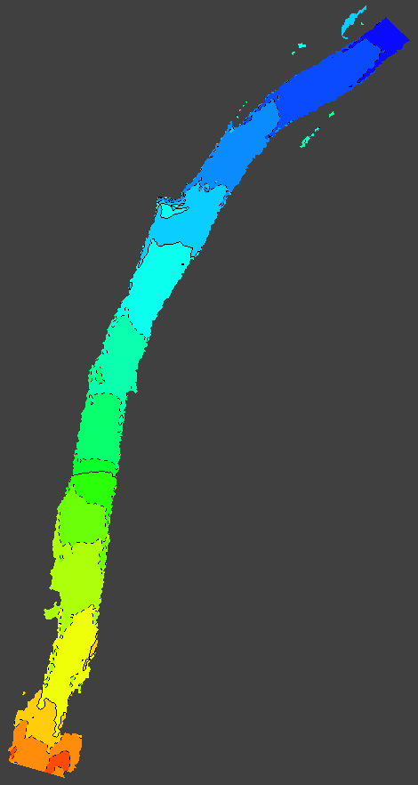

Figure 43. Results after 4,000 time steps (left) and after 6,000 time steps (right).

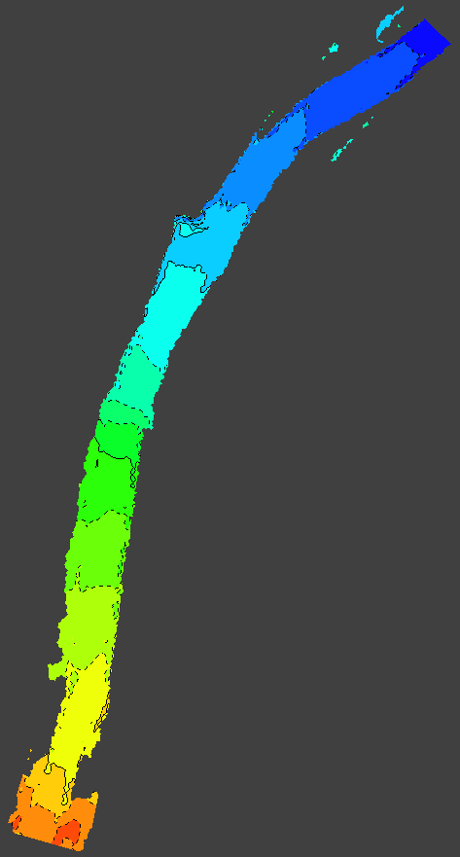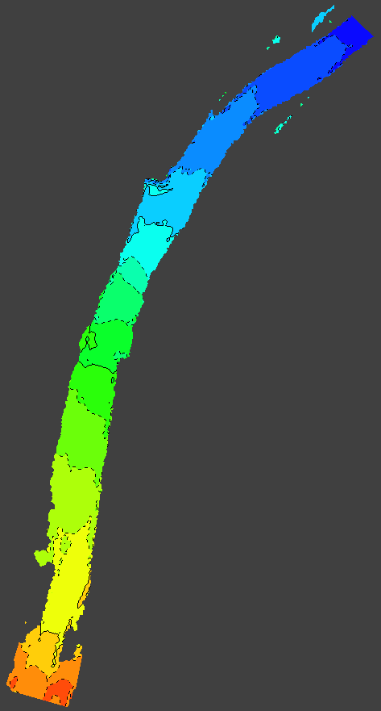

Figure 44. Results after 8,000 time steps (left) and after 10,000 time steps (right).

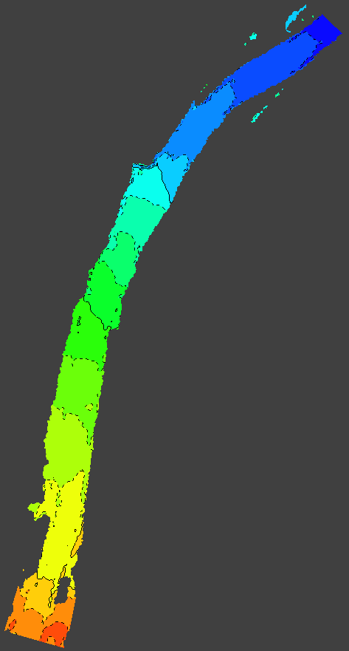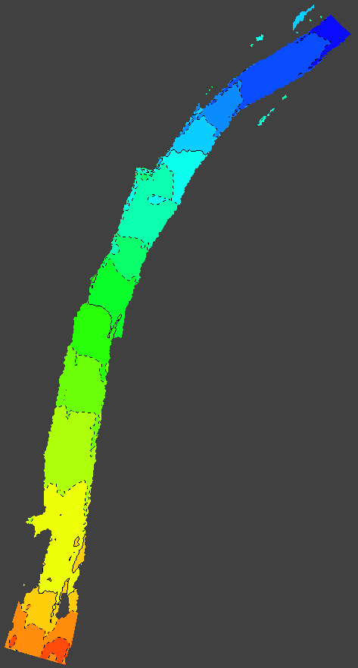

Figure 45. Results after 12,000 time steps (left) and after 14,000 time steps (right).

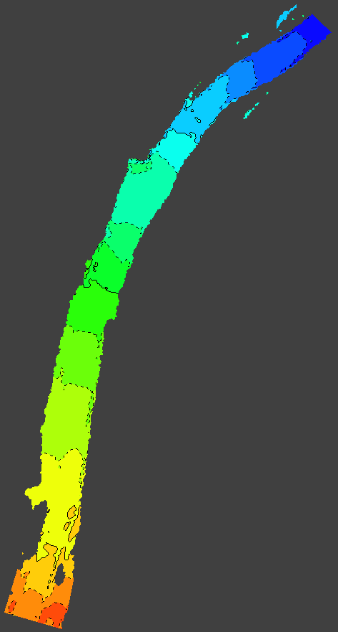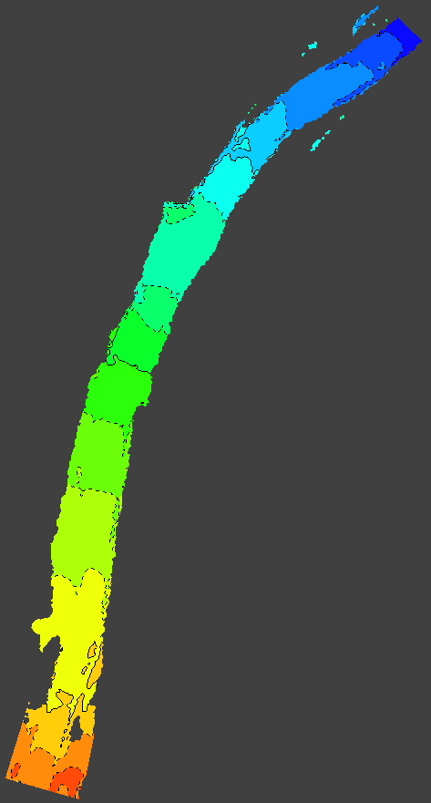

Figure 46. Results after 16,000 time steps (left) and after 18,000 time steps (right).

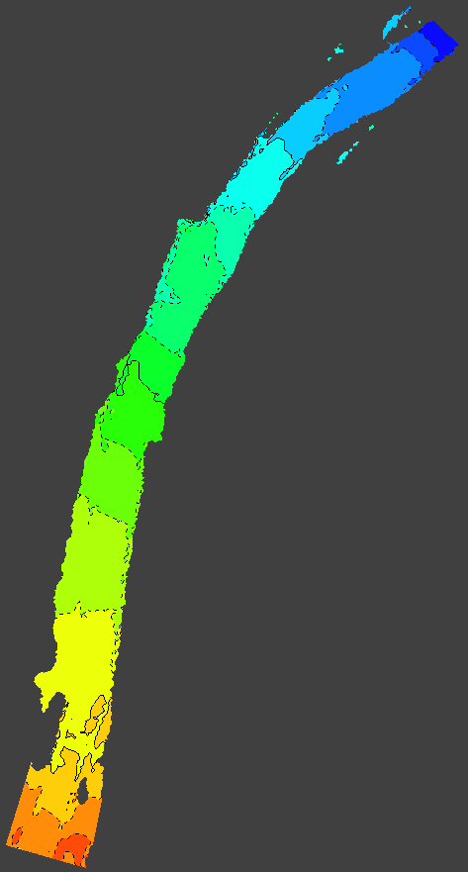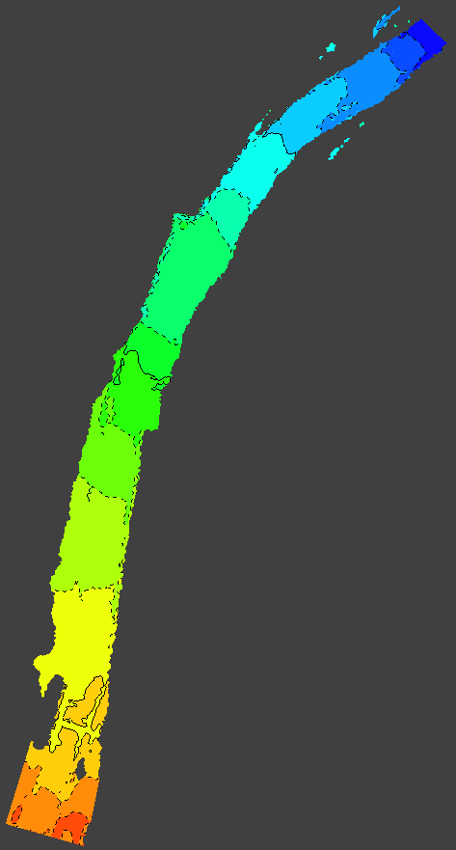

Figure 47. Results after 20,000 time steps (left) and after 22,000 time steps (right).

MD_SWMS also allows the use of variable outflow boundary conditions. The steps to set-up such a boundary are identical to those followed in this section, but they would have to be applied to the Nodestring_1 boundary.

